Analyses of the bias:

Direct Bias

Analyses of the model:

Average training accuracy

Average loss

F1 score

Significance testing between the biased and debiased models.

**Average length of article + title = 2501.139**

Experiment 1: 10 times validation, **debiased**

(training):

Plot of loss vs. epochs

Plot of accuracy vs epochs

Copy and paste the training output messages and I’ll use excel to do the plot.

(Validation):

F1 score (validation) - average over 10 iterations

Average accuracy (validation) - average over 10 iterations

Precision/Recall (validation) - average over 10 iterations

Model 1: trained on title only, debiased:

| Trial | 1 | 2 | 3 | Average | Standard Deviation |
| --- | --- | --- | --- | --- | --- |
| Loss  (training) | 0.18089881 | 0.14086728 | 0.17934328 | 0.1670364567 | 0.018515295910024 |
| Accuracy (training) | 0.93686484 | 0.95071138 | 0.93918318 | 0.94225313333333 | 0.0060553077320388 |
| F1 (Validation) | 0.9358685074854036 | 0.9527885037556577 | 0.9387530206357383 | 0.9424700106256 | 0.0073906959250534 |
| Accuracy  (validation) | 0.9367397314375987 | 0.953559439178515 | 0.9397857424960505 | 0.94336163770405 | 0.0073173725715556 |
| Precision  (validation) | 0.9369433688067061 | 0.9531544936757275 | 0.9392670501123541 | 0.9431216375316 | 0.007157444865741 |
| Recall  (validation) | 0.9366999772067868 | 0.9543591500597388 | 0.9404111451556282 | 0.94382342414072 | 0.0076023826250579 |

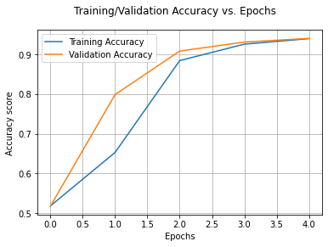

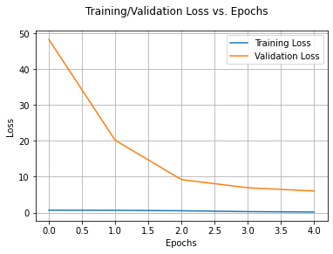

Experiment 2: 10 times validation, **biased**

(training):

Plot of loss vs. epochs

Plot of accuracy vs epochs

(Validation):

F1 score (validation) - average over 10 iterations

Average accuracy (validation) - average over 10 iterations

Precision/Recall (validation) - average over 10 iterations

| Trial | 1(10 epochs) | 2 | 3 | 4 | Average | Standard Deviation |
| --- | --- | --- | --- | --- | --- | --- |
| Loss  (training) | 0.06683326 | 0.16314942 | 0.16797628 | 0.17566839 | 0.16893136333333 | 0.0051552750069182 |
| Accuracy (training) | 0.97640371 | 0.94162856 | 0.93965955 | 0.93607088 | 0.93911966333333 | 0.0023008056495111 |
| F1 (Validation) | 0.9735649614834727 | 0.943778336716947 | 0.9404953490652207 | 0.9366275663113004 | 0.94030041736449 | 0.0029225420583835 |
| Accuracy  (validation) | 0.9740077014218009 | 0.944599131121643 | 0.9415629936808847 | 0.9375 | 0.94122070826751 | 0.0029082967694428 |
| Precision  (validation) | 0.9744629635834753 | 0.9442991650474493 | 0.9416120561465404 | 0.9375782958303236 | 0.94116317234144 | 0.0027620817344037 |
| Recall  (validation) | 0.9735744425163435 | 0.944907986599725 | 0.9410638830632838 | 0.9378312999378188 | 0.94126772320028 | 0.0028926385450873 |

